STUDENT PERFORMANCE ANALYSIS
PROGRAM:
import numpy as np
import pandas as pd
import matplotlib.pyplot as plt
import seaborn as sns
from sklearn.model_selection import train_test_split
from sklearn.preprocessing import StandardScaler
from sklearn.linear_model import LogisticRegression
from sklearn.metrics import accuracy_score, confusion_matrix
np.random.seed(42)
data = pd.DataFrame({
"Maths": np.random.randint(40, 100, 100),
"Science": np.random.randint(40, 100, 100),
"English": np.random.randint(40, 100, 100),
"History": np.random.randint(40, 100, 100),
"Geography": np.random.randint(40, 100, 100)
})
# Create target (Pass/Fail)
data["Average"] = data.mean(axis=1)
data["Result"] = (data["Average"] >= 60).astype(int)
print("Dataset Sample:\n", data.head())
print("\nAverage Marks:\n", data.mean())
print("\nStandard Deviation:\n", data.std())
corr = data.corr()
plt.figure()
sns.heatmap(corr, annot=True)
plt.title("Correlation Heatmap")
plt.show()
plt.figure()
data["Average"].hist()
plt.title("Average Score Distribution")
plt.show()

sample = data["Average"].sample(30)
mean = sample.mean()
std = sample.std()
n = len(sample)
z_score = (mean - 60) / (std / np.sqrt(n))
print("\nZ-Score:", z_score)
if z_score > 1.96:
print("Reject Null Hypothesis")
else:
print("Accept Null Hypothesis")
X = data[["Maths", "Science", "English", "History", "Geography"]]
y = data["Result"]
X_train, X_test, y_train, y_test = train_test_split(X, y, test_size=0.2)
scaler = StandardScaler()
X_train = scaler.fit_transform(X_train)
X_test = scaler.transform(X_test)
model = LogisticRegression()
model.fit(X_train, y_train)
y_pred = model.predict(X_test)
print("\nModel Accuracy:", accuracy_score(y_test, y_pred))
sns.heatmap(confusion_matrix(y_test, y_pred), annot=True)
plt.title("Confusion Matrix")
plt.show()
new_student = [[80, 75, 70, 65, 60]]
prediction = model.predict(scaler.transform(new_student))
print("\nNew Student Prediction:")
print("Pass" if prediction[0] == 1 else "Fail")

OUTPUT:
Dataset Sample:
Maths Science English History Geography Average Result
0 78 53 46 72 46 59.0 0
1 91 62 98 48 42 68.2 1
2 68 99 90 99 56 82.4 1
3 54 96 61 98 72 76.2 1
4 82 79 67 45 87 72.0 1

Average Marks:
Maths 69.580
Science 69.070
English 71.140
History 69.740
Geography 72.450
Average 70.396
Result 0.940
dtype: float64

Standard Deviation:
Maths 18.031499
Science 16.811645
English 18.602715
History 17.497832
Geography 15.720009
Average 7.524021
Result 0.238683
dtype: float64
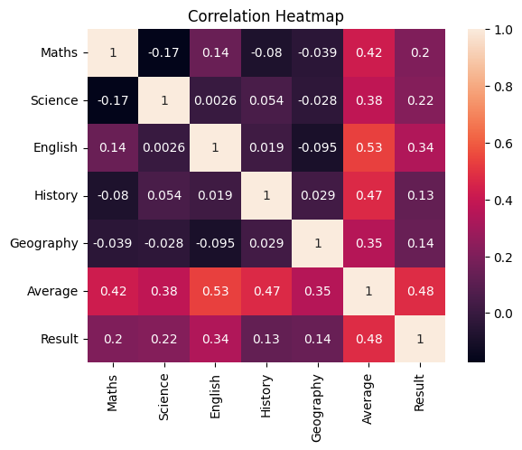
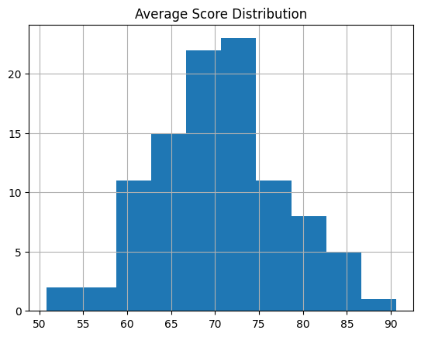

Z-Score: 7.412825505533413
Reject Null Hypothesis

Model Accuracy: 0.9
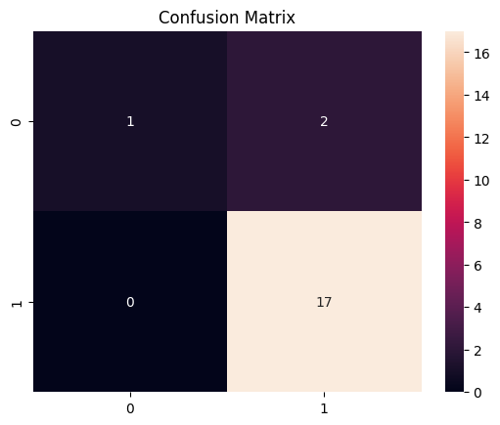

New Student Prediction:
Pass

